**Nand gate as Universal gate**

**(A.B)’  = A’+B’**

NAND gate is actually a combination of two logic gates i.e. AND gate followed by NOT gate. its output is complement of the output of an AND gate.

This gate can have minimum two inputs.

By using only NAND gates, we can realize all logic functions: AND, OR, NOT, Ex-OR, Ex-NOR, NOR.

this gate is also called as universal gate.

#### **NAND gates as OR gate**

From DeMorgan’s theorems:  
(A.B)’ = A’ + B’  
(A’.B’)’ = A’’ + B’’ = A + B  
So, give the inverted inputs to a NAND gate, obtain OR operation at output.

#### **NAND gates as AND gate**

A NAND produces complement of AND gate. So, if the output of a NAND gate is inverted, overall output will be that of an AND gate.

**Y = ((A.B)’)’**  
**Y = (A.B)**

#### **NAND gates as Ex-OR gate :**

The output of a two input Ex-OR gate is shown by: Y = A’B + AB’. This can be achieved with the logic diagram shown in the left side.

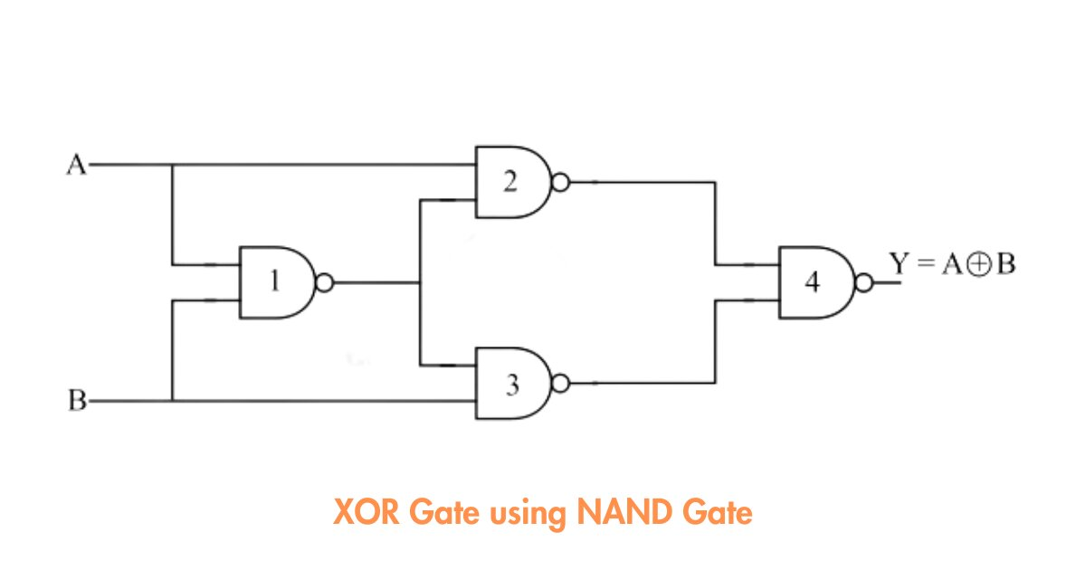

#### **NAND gates as Ex-NOR gate**

Ex-NOR gate is actually Ex-OR gate followed by NOT gate. So give the output of Ex-OR gate to a NOT gate, overall output is that of an Ex-NOR gate.

**Y = AB+ A’B’**

### Nor gate as Universal Gate

### NOR gate is actually a combination of two logic gates: OR gate followed by NOT gate. So its output is complement of the output of an OR gate.This gate can have minimum two inputs, output is always one. By using only NOR gates, we can realize all logic functions: AND, OR, NOT, Ex-OR, Ex-NOR, NAND. So this gate is also called universal gate.

#### **NOR gates as OR gate**

A NOR produces complement of OR gate. So, if the output of a NOR gate is inverted, overall output will be that of an OR gate.

**Y = ((A+B)’)’  
Y = (A+B)**

#### **NOR gates as AND gate**

From DeMorgan’s theorems:  
(A+B)’ = A’B’  
(A’+B’)’ = A’’B’’ = AB  
So, give the inverted inputs to a NOR gate, obtain AND operation at output.

#### **)NOR gates as Ex-OR gate**

Ex-OR gate is actually Ex-NOR gate followed by NOT gate. So give the output of Ex-NOR gate to a NOT gate, overall output is that of an Ex-OR gate.  
Y = A’B+ AB’

#### **NOR gates as Ex-NOR gate**

The output of a two input Ex-NOR gate is shown by: Y = AB + A’B’.

**Nand gate to implement half adder**

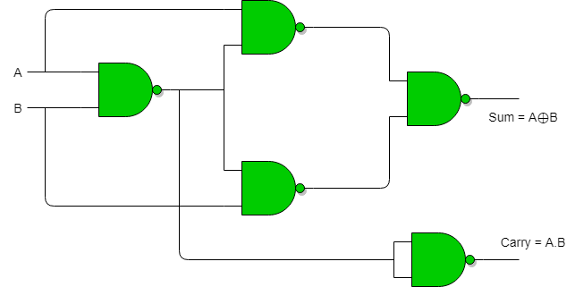

**Implementation of Half Adder using NOR gates :** Total 5 NOR gates are required to implement half adder.

**Implementation of Half Subtractor using NAND gates :** Total 5 NAND gates are required to implement half subtractor.

**Implementation of Half Subtractor using NOR gates :** Total 5 NOR gates are required to implement half subtractor.

**For other logic equations ; To implement any Boolean logic using NAND GATES**

1. Convert equation into SOP FORM
2. Draw a logic diagram based on sop
3. Convert AND into Nand & OR into Bubbled OR
4. Balance out the bubbles or inverter

**For other logic equations ; To implement any Boolean logic using NOR GATES**

1. Convert equation into POS FORM
2. Draw a logic diagram based on POS
3. Convert AND into BUBBLED AND & OR into NOR
4. Balance out the bubbles or inverter